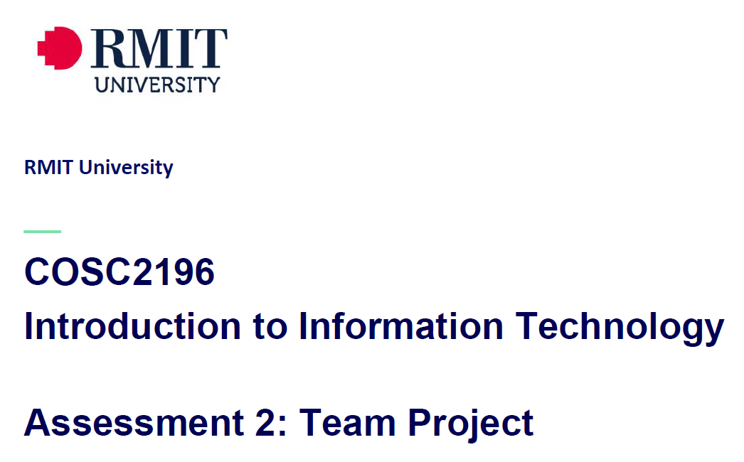
Team_Name_404 MEETING
Venue: Online via MS Teams
Date: 29/4/21

Agenda

Meeting Opened: (time)
Attendance: Paul Eccarius, Rebecca Watson, Martin Lee, Nour Zeroual
Apologies:

- Housekeeping/feedback on group process from A2:
- What is the best way to make use of MS Teams? (Bec)

- Has everyone had a chance to read through the Assignment?

- Appoint a Team Leader for A3/5:

ASSIGNMENT 3: Our IT Project (overall weighting 40%)

- Team Profile – 5%

- Tools – 5%

- Project Plan/Description – 50%

- Overview:
- Detailed Description:
Aims
Plans & Progress
Roles
Scope and Limits
Tools & Technologies
Testing
Timeframe
Risks
Group Processes & Communications

- Skills and Jobs – 15%

- Feedback – 7.5%

- Group Reflection – 7.5%
- Presentation – 10%

Assignment 5: Presentation (overall weighting 20%)

- Draft script + storyboard is due Sunday of Week 10
- Specifics as per rubric:
Identification/Description
Need/Want/Users/Market
Innovation
Mechanics/Design
Length
Quality

- Additional points for discussion?

Next meeting date:
Meeting closed: (time)

Actions Register

Meeting Date | Action | Who to action | Completed Y/N | Update at meeting | Further action

